Slide 1: SQL JOINS - Introduction & INNER JOIN
What is a JOIN?
A JOIN is used to combine data from multiple tables based on a common field.
Why are Joins Important?
- Data is usually stored in separate tables.
- Joins help retrieve related information efficiently.
- They reduce data duplication and improve database design.
INNER JOIN
Returns only the records that have matching values in both tables.
Example:
Employees who belong to existing departments.
Shows only common data between tables
Most frequently used JOIN
Visual Idea:
Two overlapping circles → Show only the overlapping part.

Slide 2: OUTER JOINS (LEFT, RIGHT & FULL)
LEFT JOIN
Returns all records from the left table and matching records from the right table.
Use Case: Find employees even if they are not assigned to any department.

RIGHT JOIN
Returns all records from the right table and matching records from the left table.
Use Case: Find departments even if no employees belong to them.

FULL OUTER JOIN
Returns all records from both tables, whether matching or not.
Use Case: Complete comparison of two tables.

Quick Comparison
- INNER JOIN → Matching records only
- LEFT JOIN → All Left + Matching Right
- RIGHT JOIN → All Right + Matching Left
- FULL JOIN → All records from both tables
Visual Idea:
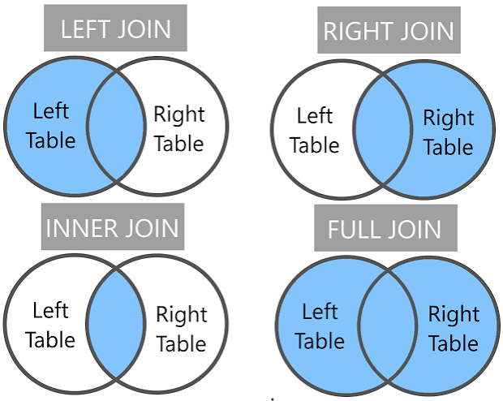

Slide 3: CROSS JOIN & SELF JOIN
CROSS JOIN
Returns every possible combination of rows from two tables.
Result Size:
Rows in Table A × Rows in Table B
Use Cases
- Product combinations
- Test data generation
- Creating permutations

SELF JOIN
A table joined with itself to compare or relate rows within the same table.
Common Uses
- Employee → Manager relationships
- Organizational hierarchy
- Parent → Child relationships
Example:
Finding which manager supervises each employee using the same Employees table.

